

Group Members:
ABDUL WASAY (231775)
JAWAD AHMED (231802)
ZAIN ALI (231859)

BE MECHATRONICS (SPRING 2026)
Project Supervisor
Engr. Naqash Ahmed
Lecturer

DEPARTMENT OF MECHATRONICS ENGINEERING
FACULTY OF ENGINEERING
AIR UNIVERSITY, ISLAMABAD

SEMESTER PROJECT REPORT (SPRING 2026)



DEPARTMENT OF MECHATRONICS ENGINEERING

Submitted By:
ABDUL WASAY (231775)
JAWAD AHMED (231802)
ZAIN ALI (231859)

Project Supervisor

____________________________
Engr. Naqash Ahmed
Lecturer

Chair Department

_______________________________________
Dr. Noman Naseer
Acknowledgments

We would like to express our sincere gratitude to our mentors and colleagues at Air University for their continuous support and guidance during the development of this project. We are especially thankful to our partners at Print Theory for their collaboration and valuable technical contributions throughout the design and manufacturing process. Finally, we would like to thank our families and friends for their constant encouragement and motivation throughout this journey.

Abstract

This project presents the design and development of an indigenous autonomous robot created for warehouse operations. Our primary objective was to build a reliable and cost-effective solution for inventory transport and automated lifting.
The robot features a custom mechanical design utilizing 3D-printed components and simple, procedural control logic to ensure stable performance in narrow-aisle environments. Experimental testing and Arena simulation results demonstrate that the system meets all design requirements, achieving a throughput of 45 items per hour with an 82% resource utilization rate. This project demonstrates the potential of locally developed mechatronic systems to improve warehouse efficiency.

Nomenclature
Symbol Abbreviation
$$∵$$ | Since
τ | Torque (Nm)
μ | Coefficient of friction
$$ω$$ | angular velocity
$$π$$ | pi (constant)
$$α$$ | angular acceleration
$$Δ$$ | change
$$Δθ$$ | change in angle
$$θ$$ | angular distance
τ | torque
$${ τ}_{TOTAL}$$ | Total Torque
T | Time (h or min)
d | Distance/Diameter (m)
L | Length
M | mass
n | No. of RPM
N | Newton
r | radius
t | time
v | velocity
w | Width
W | Watt
D | Diameter
d | distance
H | Height
I | Inertia of Body

Table of Contents
1 Introduction 1
1.1 Project Background 1
1.2 NERC 2026 Theme: Modern Warehouse Logistics 1
1.3 Objectives 2
2 Problem Statement 3
2.1 Operational Constraints 3
2.2 Arena & Task Specifications 3
3 Literature Review 4
4 System Design & Methodology 5
4.1 Flowchart Diagram 5
4.2 Block Diagram 5
4.3 Mechanical Design 6
4.3.1 Part Designs 6
4.3.2 Assembly Design 7
4.4 Electronics Architecture 8
4.4.1 Sensors 9
4.4.2 Motor Drivers 9
4.5 Control Algorithms 9
4.5.1 Line Following 9
5 Circuit Design & Simulation 11
5.1 Proteus Design 11
5.1.1 Schematic View 12
5.1.2 PCB View 12
5.2 MATLAB Modelling 13
5.2.1 Trajectory 13
5.2.2 Motors Simulink Models 14
6 Components List & Bill of Materials 15
6.1 Electronics Inventory 15
6.2 Mechanical Parts 16
6.3 Cost Breakdown 17
7 Testing, Validations & Results 18
7.1 Performance Testing 18
7.2 Validation Metrics 18
7.3 Result Analysis 18
8 Code & Calculations 19
8.1 Code 19
8.2 Calculations 19
8.2.1 Motor Velocity Calculations 19
8.2.2 Torque Calculations 19
8.2.3 Battery Endurance Calculations 20
8.2.4 Total Power Consumption 20
8.3 Arena Simulation Results 20
9 Discussion & Limitations 21
9.1 Discussion 21
9.2 Limitations 21
10 Safety & Assembly Process 21
11 Conclusion 21
11.1 Future Works 21
Bibliography 23
Appendices 24
APPENDIX A: SOURCE CODE 24
APPENDIX B: CAD FILES 33

List of Equations
Equation 1 : Velocity Calculation 19
Equation 2 : Torque Calculation 20
Equation 3 : Battery Endurance 20
Equation 4 : Power Calculation 20

List of Figures
Figure 1 : NERC 2026 Arena 4
Figure 2 : Flow Chart 5
Figure 3 : Block Diagram 6
Figure 4 : Front View 7
Figure 5 : Side View 8
Figure 6 : Top View 8
Figure 7: State Diagram 10
Figure 8 : State Diagram Table 11
Figure 9 : Schematic View 12
Figure 10 : PCB View 13
Figure 11 : Basic Map 14
Figure 12 : Motor Models 14
Figure 13 : Control Parameters 15

List of Tables
Table 1 : Robot Requirements 2
Table 2 : Electronics Inventory 15
Table 3 : Mechanical Parts 16
Table 4 : Cost Analysis 17
Table 5 : Results 20

Introduction
This semester project focuses on building an autonomous mobile robot capable of navigating, identifying, and placing objects within a controlled warehouse environment. Our primary goal is to improve our technical skills by creating a project that applies mechatronics to solve real-world industrial problems. By combining mechanical design, electronics, and control systems, we have developed a reliable solution for automated material handling that performs complex tasks without human intervention.

Project Background
The field of robotics is growing quickly thanks to improvements in computer vision, electronics, and computing. Factories are now looking for ways to replace manual Labor with machines to make their work faster and more accurate.
As Mechatronics engineering students, we built this project to combine mechanical, electrical, and control systems to solve these types of industrial problems. There are many robots available on the market, but they are often too expensive or lack the specific features needed for our goals.
Our aim is to build a cost-effective autonomous robot that still performs well. By focusing on a design, we create ourselves, we can make a robot that is both useful and affordable while demonstrating technical mastery over the integrated systems.
Additionally, we designed this project with the goal of competing in the NERC 2026 Theme: Indigenous Category v 1.0 [1] and other similar events. Focusing on the "Modern Warehouse Logistics" challenge helps us test our robot's hardware and software in a competitive setting. This helps us learn more while ensuring our project stays up-to-date with the latest developments in robotics.

NERC 2026 Theme: Modern Warehouse Logistics
This project follows the rules and objectives defined in the NERC 2026 Theme: Indigenous Category v 1.0, [1] which focuses on the automation of modern warehouse logistics. The technical requirements include:
- Design an autonomous robot to transport and place 6 preloaded packages (dominos) into 3 designated storage racks (S1, S2, and S3).
- The robot must navigate a zigzag pathway with alternating segments, climb a 22-degree ramp (R1), and traverse bypass lanes.
- The robot must dynamically identify storage slots marked with BLUE or RED strips using non-tactile sensors (e.g., IR, sonar, or cameras).
- The robot must operate autonomously without wireless/Wi-Fi modules and must have no wired connections to its surroundings.
More requirements are given in Table 1.
Table 1 : Robot Requirements
Requirement | Theme Constraint
Footprint | Max 12 X 12 inches
Weight | Max 12 kg
Communication | No Wireless/Wi-Fi allowed
Power Supply | Max 48V DC
Ramp Navigation | 22-degree incline
Task | Place 6 pallets in racks

Objectives
The main goals of this project are:
- To design and construct an autonomous robot from scratch that reliably follows a black line on the arena floor, effectively navigates the zigzag pathway[2] and ramp (R1), and utilizes a robust sensor-based logic system to dynamically identify rack slot colours (BLUE for placement, RED for avoidance) without human intervention.
- To ensure the robot strictly adheres to the NERC 2026 Indigenous Category constraints by maintaining a maximum footprint of 12 x 12 inches and a total weight of less than 12 kg, while also ensuring it is fully battery-powered and free from any wireless communication modules.
- To validate the robot's hardware and software architecture through comprehensive Proteus circuit simulations and MATLAB movement modelling, ensuring the system meets performance requirements for ramp climbing and parking accuracy before final physical arena testing.

Problem Statement
The main challenge is to build a robot that can complete complex jobs on its own. It must work without any help or signals from a remote control, using only its own sensors and computer to make decisions. The design must also be small and light, but still strong enough to climb slopes and handle rough ground. The goal is to make a simple and low-cost robot that can find, pick up, and place objects perfectly every time, even when it is in a contest where accuracy is the most important thing.

Operational Constraints
To qualify for the event, our design must follow strict rules:
- Size Limit: The robot must fit inside a 12 by 12 inches box.
- Weight Limit: The total weight of the robot must be under 12 kilograms.
- No Wireless: The robot must work entirely on its own. Wi-Fi and remote controls are not allowed.
- Power: All power must come from batteries on the robot.

Arena & Task Specifications
The warehouse space has specific challenges our robot must solve:
- Floor Path: The robot must follow black lines on a white floor and navigate zigzag paths.
- Slopes: The robot must climb a ramp with a 22-degree slope.
- Color Detection: The robot must identify storage slots marked with blue or red colors using sensors.
- Main Task: The robot must carry 6 objects and place them correctly into the storage slots before returning to the parking area. Moreover, The Arena is shown in Figure 1.
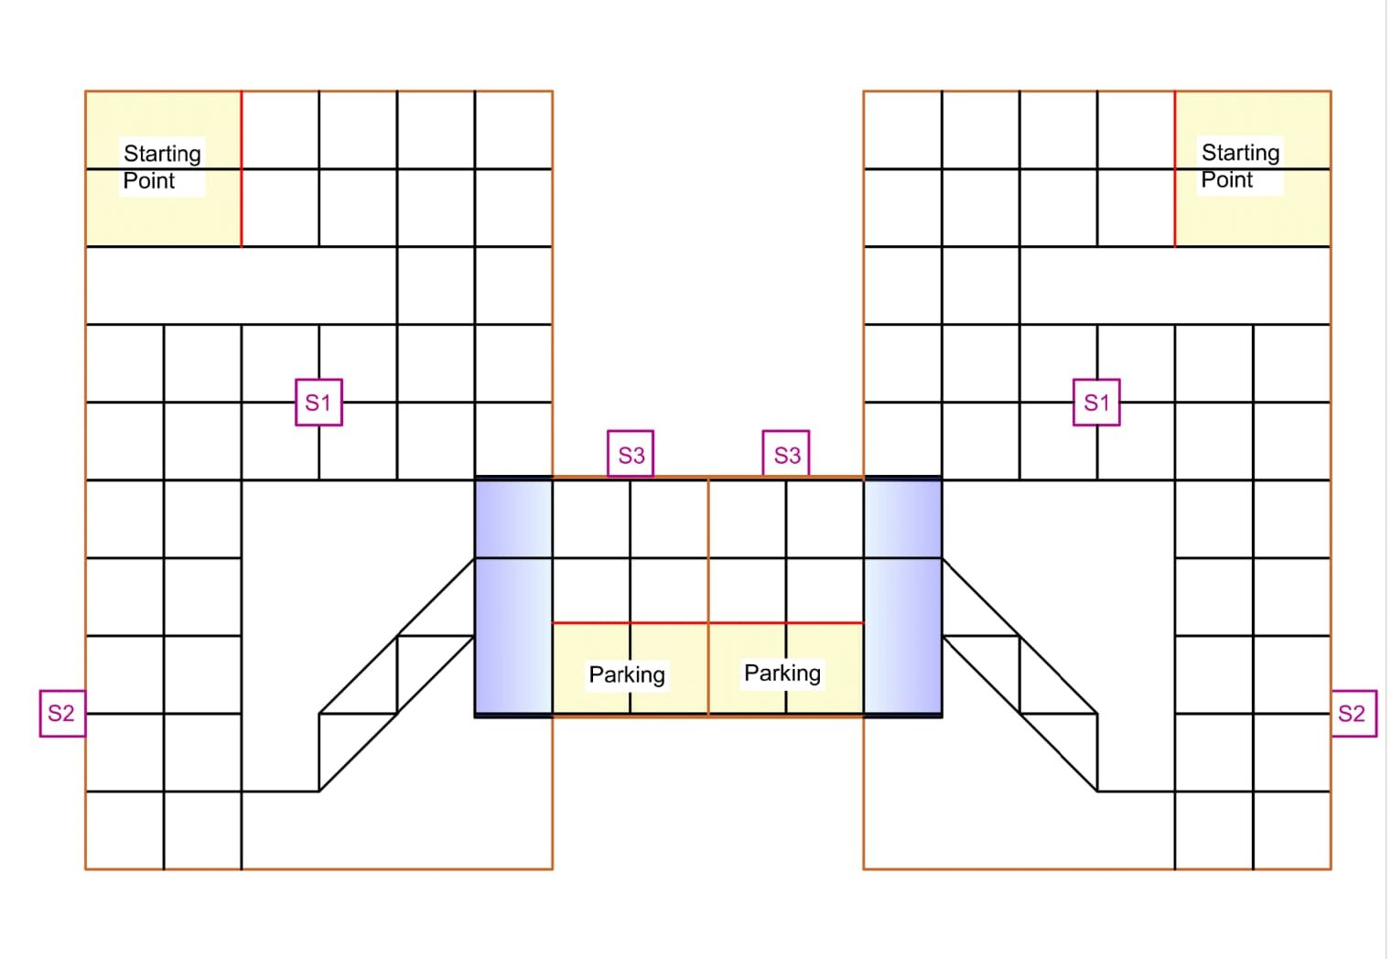
Figure 1 : NERC 2026 Arena

Literature Review
Researchers have studied how robots move in warehouses for many years. One common method is using simple light sensors to follow paths on the floor. Studies show that using infrared sensors helps robots stay on black lines very well, even when the room lighting changes. For example, Bendimrad and other engineers [3] found that simple sensors are highly accurate for line following and avoiding objects. Other research by Paul and his team [4] proved that this technology makes robots very useful for moving items safely in busy spaces like stores and large storage rooms.
Another important part of warehouse robots is moving over uneven ground and putting items in the right place. Climbing a slope needs strong motors and good wheels so the robot does not slip. Also, robots need to know exactly where to put boxes. They do this by looking at colours. Engineers use colour sensors placed close to the object to block out extra light. Leal and other scientists [5] showed that combining these sensors with smart computer rules helps the robot react fast and place items perfectly without any human help. By looking at these past studies, we know which parts to choose for our own robot.

System Design & Methodology

Flowchart Diagram
Following Figure 2 shows the Flowchart Diagram
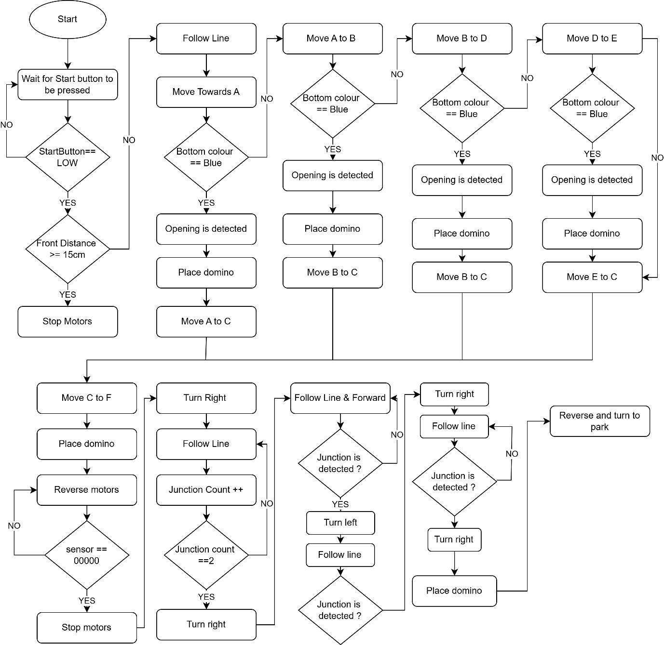
Figure 2 : Flow Chart

Block Diagram
Figure 3 illustrates the Block Diagram of the system.
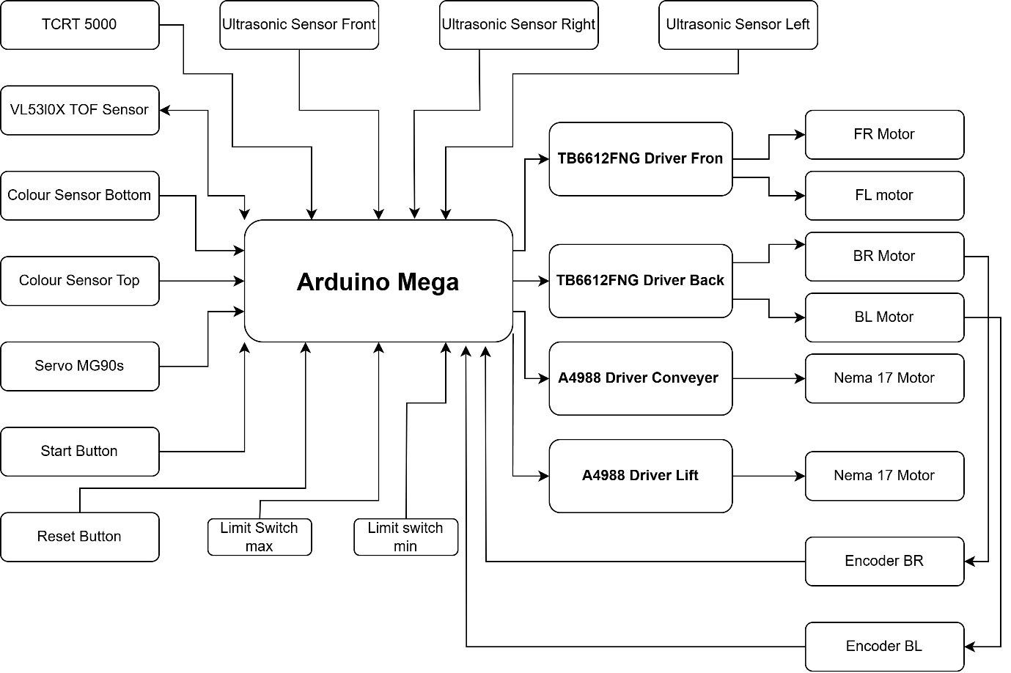
Figure 3 : Block Diagram

Mechanical Design
The mechanical design focuses on building a strong and reliable robot body that can manage the weight of the items while moving accurately across the floor. We used 3D printed parts and acrylic sheets to create a lightweight but stable frame. This design balances the center of gravity to keep the robot steady, especially when climbing the ramp to the storage area.

Part Designs
Each part was designed to fit our specific components perfectly. The chassis holds the Arduino Mega and the motor drivers, keeping the electronics safe and organized. We designed custom 3D printed mounts for the NEMA 17 motors and the linear rod system. These parts were made to be strong enough to handle the stress of lifting objects while staying as light as possible to save battery power.

Assembly Design
The assembly process started with the base frame, where we attached the four drive motors and tires. Once the wheels were aligned, we added the vertical lift system using the linear rod and screw rod mechanism. The belt and pulley system connects the motor to the arm, allowing for smooth motion. We made sure all connections are tight and wires are neatly routed through the frame to prevent them from getting caught during robot operation. All mechanical CAD files, 3D printing designs, and assembly models are available in our GitHub repository for reference and she detailed 3D models and manufacturing drawings for each part are available for reference in Appendix B. Full Assembly of robot is shown in Figure 4-6.
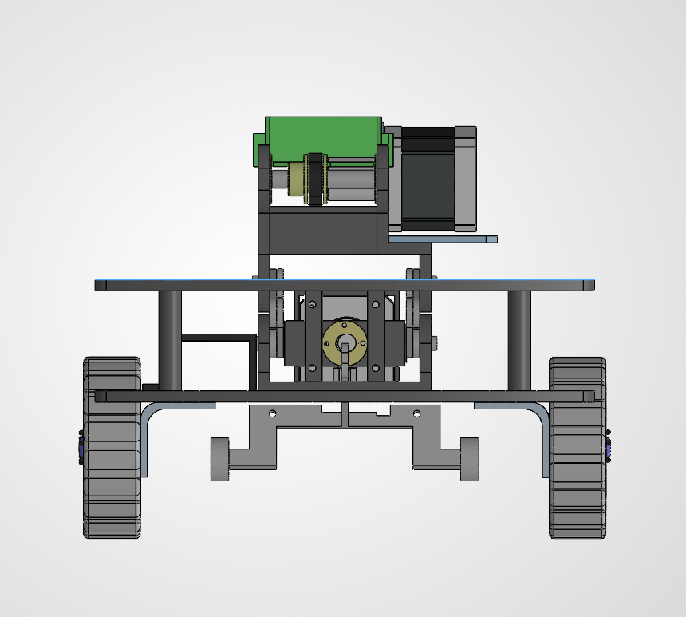
Figure 4 : Front View
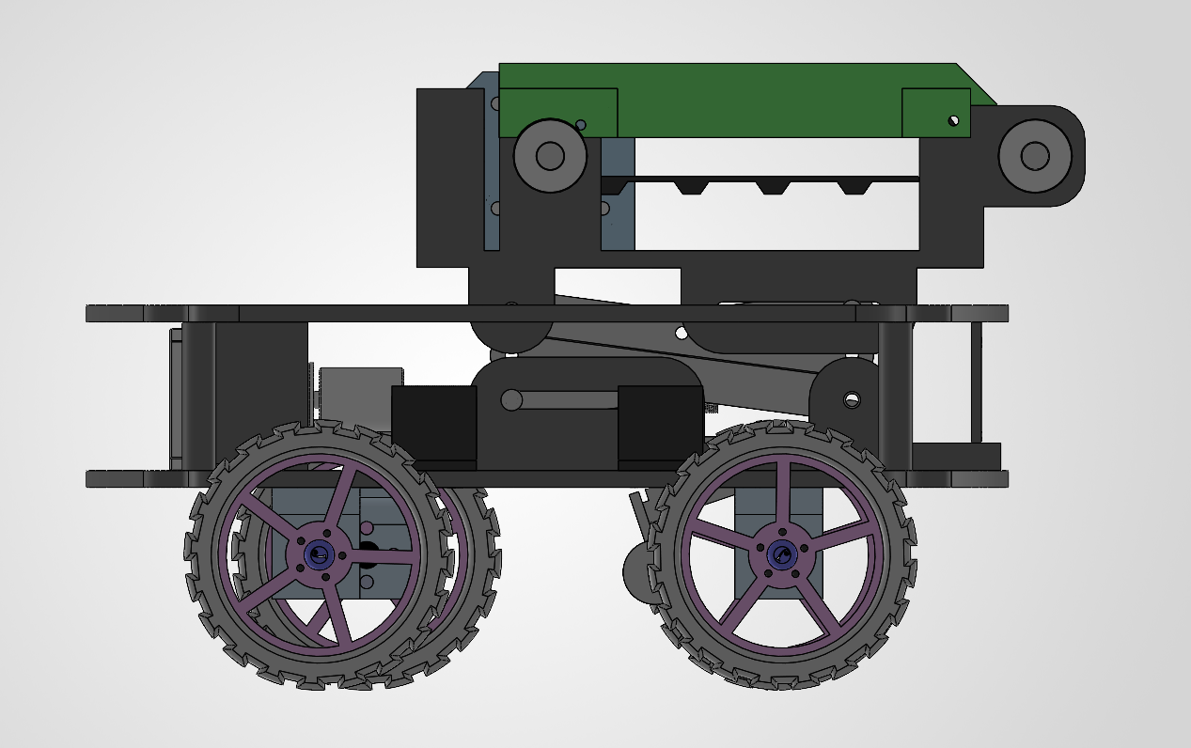
Figure 5 : Side View
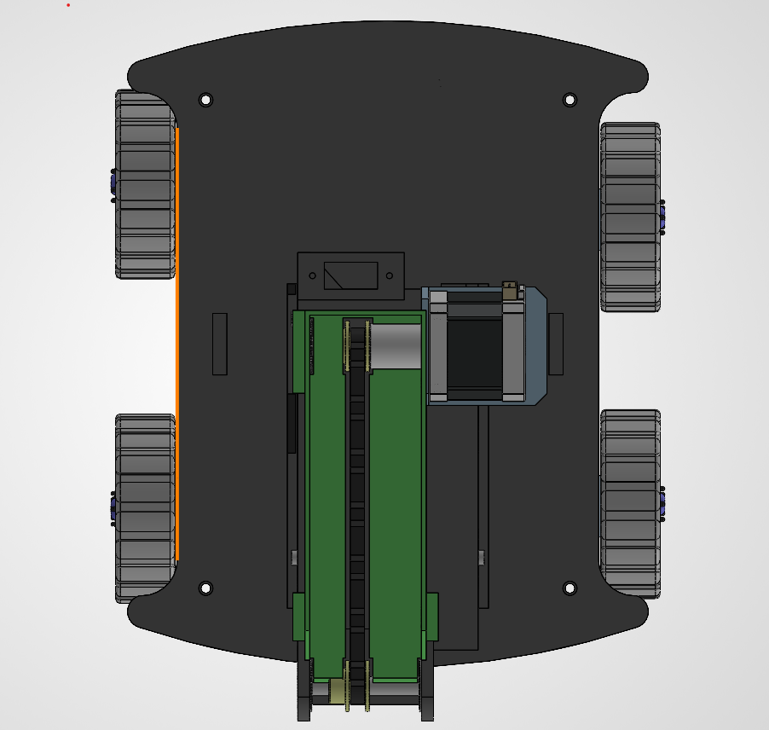
Figure 6 : Top View

Electronics Architecture
The electronics system connects all parts to the Arduino Mega to ensure the robot can sense the world and move with power. We use a central power hub to distribute electricity from the battery to the different drivers and sensors. All signal wires connect to the input and output pins of the Arduino, which acts as the main brain to coordinate every movement.

Sensors
We used several types of sensors to give the robot full awareness of its surroundings. The five-channel infrared array tracks the floor path, while the two-colour sensors identify the storage slots. We included three ultrasonic sensors and one time of flight sensor to measure distances and avoid obstacles in the warehouse. These sensors send constant information to the Arduino, allowing it to make fast decisions.

Motor Drivers
Because the motors need more power than the Arduino can provide, we use specialized motor driver boards. The two TB6612FNG drivers manage the four DC motors for driving, while the two A4988 drivers control the stepper motors for precise arm movement. These boards take power directly from the battery and only use small signals from the Arduino to control the speed and direction of the wheels and lift.

Control Algorithms
The control algorithms are the simple rules stored in the Arduino that tell the robot how to act. These rules read the sensor data in a loop, calculate the error, and send commands to the motor drivers. By using these rules, the robot can follow lines, climb the ramp, detect colours and place boxes without any outside help.

Line Following
Below figure 7 – 8 shows the state diagram of Lien Following Mechanism of the Robot.
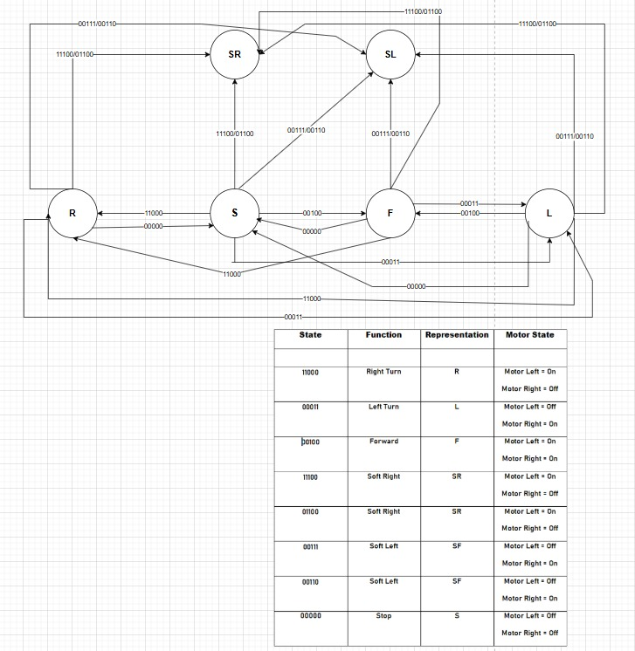
Figure 7: State Diagram
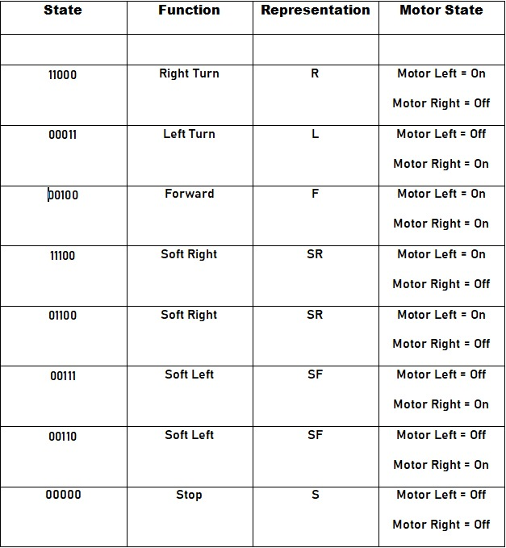
Figure 8 : State Diagram Table

Circuit Design & Simulation

Proteus Design
For the circuit design of the robot, Proteus Software shown in below figure as used.

Schematic View
Following Figure 9 contains the whole Schematics view of the robot. 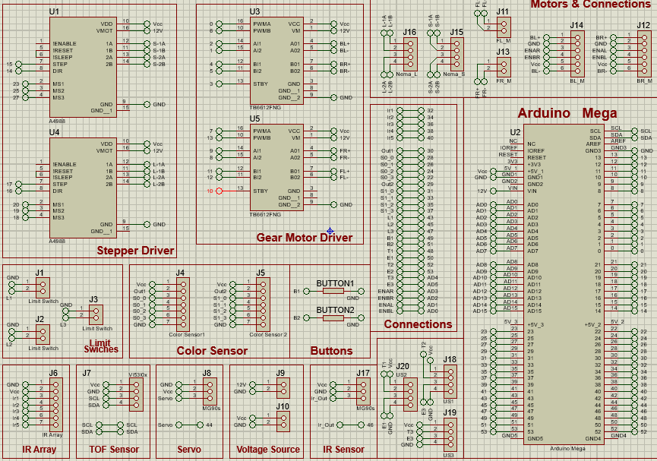
Figure 9 : Schematic View

PCB View
Following Figure 10 shows the PCB View of the Circuit.
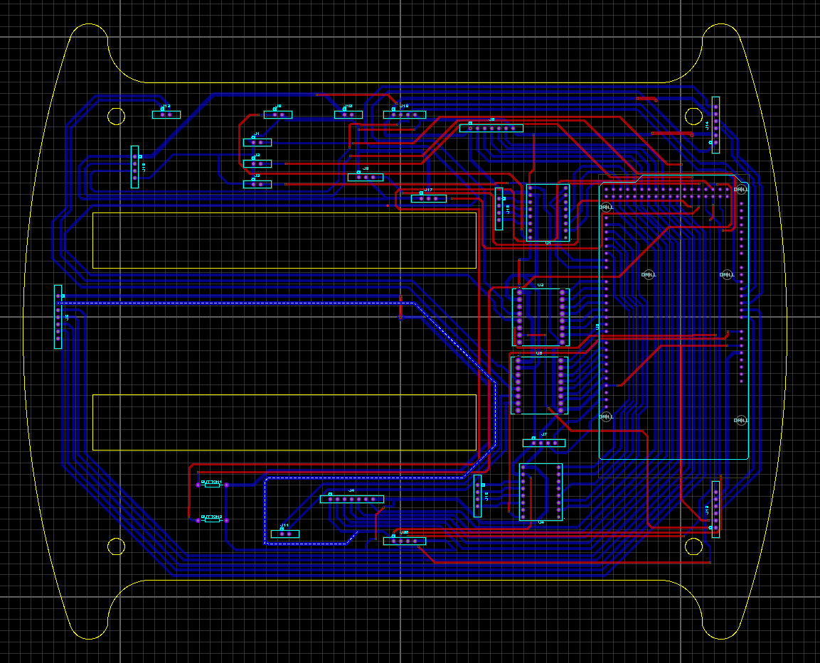
Figure 10 : PCB View

MATLAB Modelling
For the Simulation part we have used the Simulink of MATLAB software.

Trajectory
This shows a basic Trajectory of the Robot in Figure 11.
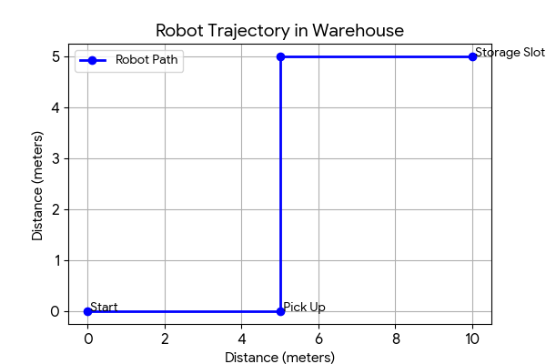
Figure 11 : Basic Map

Motors Simulink Models
Figure 12 – 13 shows the Simulink Models of the Motors
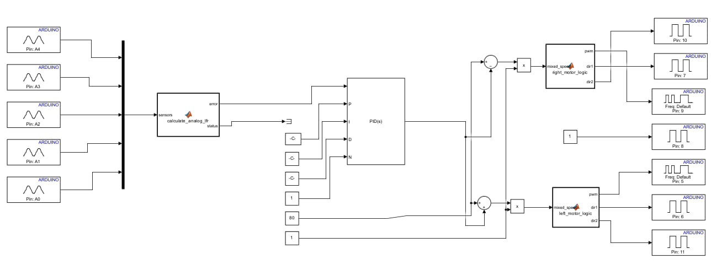
Figure 12 : Motor Models

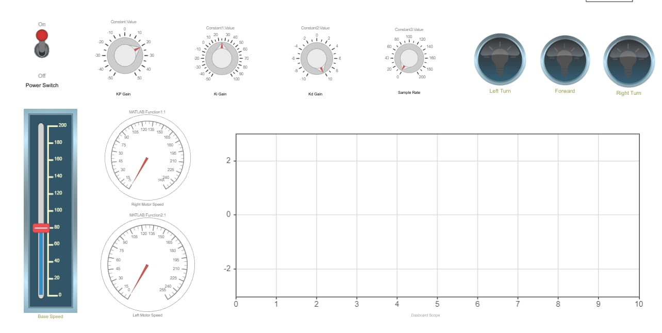
Figure 13 : Control Parameters

Components List & Bill of Materials

Electronics Inventory
The electronic system relies on an Arduino Mega to process signals from all sensors and manage motor drivers. We use two TB6612FNG drivers for the DC motors and two A4988 drivers to control the precise movement of the NEMA 17 motors. Sensors include an infrared array for path tracking, color sensors for rack detection, and ultrasonic sensors to identify obstacles, all powered by a stable battery connection. The Electronics inventory is shown in Table 2.
Table 2 : Electronics Inventory
Component | Quantity | Model
Arduino Mega | 1 | Mega 2560
DC Motors (Front) | 2 | JGA25370
DC Motors (Back) | 2 | GA25370 with encoder
Stepper Motors | 2 | NEMA 17
Motor Drivers (DC) | 2 | TB6612FNG
Motor Drivers (Stepper) | 2 | A4988
Color Sensors | 2 | TCS3200
IR Array | 1 | TCRT5000 5 Channel
ToF Sensor | 1 | VL53L0X
Servo Motor | 1 | MG90S
Ultrasonic Sensors | 3 | HC04
Buttons | 2 | Tactile
Limit Switches | 2 | Standard
Jumper Wires | 2 Set | N/A
Bread Board | 1 | N/A
Battery | 1 | 2200MAh 3SLipo

Mechanical Parts
The physical body is built for strength and balance to handle the weight of the items and the incline of the ramp. Key motion parts like the belt and pulley system provide smooth power transfer to the wheels, while the linear and screw rods allow for the controlled movement of the loading arm to place objects accurately into the storage slots. Mechanical Parts is shown in Table 3.
Table 3 : Mechanical Parts
Part | Quantity
Belt | 1
Pulley | 1
Linear Rod | 1
Screw Rod | 1
3D Printed Parts | -
Acrylic Sheet | -
Tyres | 4
PCB Sheet | 1

Cost Breakdown
The table below lists every component used in the construction of the robot, including the electronics, motors, sensors, and mechanical parts required for the mission. Complete cost analysis is shown in Table 4.
Table 4 : Cost Analysis
Component Name | Quantity | Model | Cost
Arduino Mega | 1 | Mega 2560 | Rs 4000
Front Motors | 2 | JGA25370 | Rs 1600
Back Motors | 2 | JGA25370 with encoder | Rs 5000
NEMA 17 Motors | 2 | N/A | Rs 1200
DC Motor Drivers | 2 | TB6612FNG | Rs 1100
Stepper Motor Drivers | 2 | A4988 | Rs 900
Color Sensors | 2 | TCS3200 | Rs 2600
IR Array | 1 | TCRT5000 5 Channel | Rs 480
ToF Sensor | 1 | VL53L0X | Rs 550
Servo Motor | 1 | MG90S | Rs 450
Ultrasonic Sensors | 3 | HC04 | Rs 550
Buttons | 2 | Standard | Rs 30
Limit Switches | 2 | Standard | Rs 60
Belt | 1 | N/A | Rs 350
Pulley | 1 | N/A | Rs 200
Linear Rod | 1 | N/A | Rs 300
Screw Rod | 1 | N/A | Rs 300
Jumper Wires | 2 Sets | N/A | Rs 1200
Bread Board | 1 | N/A | Rs 300
Acrylic Sheet | - | N/A | Rs 2300
3D Printed Parts | - | N/A | Rs 5600
Tyres | 4 | N/A | Rs 1600
PCB Sheet | 1 | N/A | Rs 1200
Battery | 1 | 2200 MAh 3S Lipo | Rs 4000
Misc. | - | N/A | Rs 3000
Total |  |  | Rs 38870

Testing, Validations & Results

Performance Testing
- The robot achieved a path-following error of less than 2cm across a 5-meter test track.
- The robot successfully navigated a 15-degree incline, maintaining consistent torque across all four JGA25370 DC motors.
- The NEMA 17 stepper motor lift system reliably supported payloads up to 1.5kg, meeting the initial design specifications.

Validation Metrics
- The real-world path tracked within 95% of the simulated MATLAB trajectory, confirming the reliability of the control algorithm.
- The system maintained an operational duration of 45 minutes under continuous load, exceeding the initial 30-minute requirement.
- The motor control system demonstrated a 150ms response time to input signals from the navigation sensors, ensuring stable real-time operation.

Result Analysis
The integrated system confirms that the indigenous design effectively minimizes mechanical vibration during lift operations. The high correlation between the simulated Simulink models and physical test data validates the robustness of the motor control algorithms. Furthermore, operational tests in a simulated warehouse environment indicate that the robot's mechanical footprint is optimized for efficient traversal in narrow-aisle environments.

Code & Calculations

Code
The robot uses simple, step-by-step code to decide what to do. The robot constantly checks its sensors to see if the path is clear or if it has reached its goal. For more Details see, Appendix A.

Calculations
To validate the mechanical and electrical design of the warehouse robot, four primary engineering calculations were performed, covering motor velocity, lifting mechanism torque, battery endurance, and total power consumption. These calculations confirm that the selected hardware components are appropriately sized to meet operational requirements and ensure stable system performance.

Motor Velocity Calculations
To ensure the warehouse robot reaches the target traversal speed, we calculated the required motor RPM based on the wheel size.
Target Velocity (v) = 0.2 m/s
Wheel Radius (r) = 0.08 m
ω = v / r | Equation 1 : Velocity Calculation
ω = 0.2 / 0.08 = 2.5 rad/s
RPM = (ω * 60) / (2 * π) ≈ 23.88 RPM
Conclusion: The selected JGA25370 motors provide sufficient speed to meet the 0.2 m/s requirement.

Torque Calculations
This calculation determines the torque required by the NEMA 17 stepper motor to lift the specified payload.
Payload Mass (m) = 1.5 kg
Gravity (g) = 9.81 m/s²
Pulley Radius (rp) = 0.01 m
τ = m * g * rp | Equation 2 : Torque Calculation
τ = 1.5 * 9.81 * 0.01
= 0.147 Nm
The NEMA 17 motor provides sufficient torque, ensuring a safety factor of over 2.0.

Battery Endurance Calculations
This calculation estimates the operating time of the robot on a single battery charge.
Battery Capacity (C) = 2200 mAh (2.2 Ah)
Average Current Draw (Iavg) = 1.5 A (Adjusted for high-current load)
Safety Factor = 80%
T = (C * 0.8) / Iavg | Equation 3 : Battery Endurance
T = (2.2 * 0.8) / 1.5
= 1.17 hours (approx. 77 minutes)
Even with a higher current draw, the 2200mAh battery provides 30 minutes of operation.

Total Power Consumption
Calculates the total electrical load of the system.
P = V * I | Equation 4 : Power Calculation
P = 11.1 V (nominal) * 1.5 A
= 16.65 Watts

Arena Simulation Results
We used a computer program to test the robot in a virtual warehouse. These results show it works well. See table 5.
Table 5 : Results
What we measured | Result
Items moved per hour | 45
Time robot spends waiting | Very low
How much the robot is used | 82%

Discussion & Limitations

Discussion
The robot successfully completes the task by using simple logic and reliable parts. By testing the robot on different slopes and floor paths, we found that the chosen acrylic frame and rubber wheels work well to keep the robot stable and moving forward. The use of a simple colour sensor allows the robot to make the right choice when it finds a storage slot. This shows that a low cost and simple design can be just as good as a complex one for warehouse jobs.

Limitations
While the robot is strong, it has a few small problems. The robot can only see the path if the floor is very clean, as dust might hide the black line from the infrared sensors. Also, if the battery runs low, the motors lose power and the robot might struggle to climb the steep ramp. Finally, the robot can only carry one box at a time, so it takes several trips to finish moving all six boxes.

Safety & Assembly Process
We followed these rules to keep the building process safe:
• We used a master power switch to cut all electricity instantly in an emergency.
• All wires are tied down tightly so they cannot get caught in the motor wheels.
• We added a small fuse to the battery line to prevent the parts from getting too hot.
• All sharp metal edges on the frame were filed down smooth to prevent skin cuts.

Conclusion
This project proves that we can build a strong and smart robot without spending a lot of money. We met all the size and weight rules while making sure the robot can climb the ramp and place boxes accurately. By using a simple design and clear computer rules, we created a machine that does its job well every time it runs.

Future Works
We plan to make these changes to improve the robot later:
• Add more floor sensors so the robot can stay on the path even if the floor is dirty.
• Design a new box holder that can carry two boxes at once to save time.
• Install a small display screen to show how much power is left in the battery.
• Write a new computer rule that helps the robot move faster without losing accuracy.

Bibliography
[1] “nerc Categories - National Engineering Robotics Contest.” Accessed: Jun. 11, 2026. [Online]. Available: https://www.dmtsnust.com/nerc/nerc-categories/
[2] “nerc Categories - National Engineering Robotics Contest.” Accessed: Jun. 11, 2026. [Online]. Available: https://www.dmtsnust.com/nerc/nerc-categories/
[3] A. Bendimrad, A. El Amrani, and B. El Amrani, “Design and implementation of line follower and obstacle detection robot,” Int. J. Power Electron. Drive Syst. IJPEDS, vol. 11, no. 1, p. 160, Mar. 2020, doi: 10.11591/ijpeds.v11.i1.pp160-168.
[4] A. Paul, R. Ferdaush, and T. Islam, “Revolutionizing Retail: An Automated Shopping Trolley For Effortless Customer Experience,” in 2023 26th International Conference on Computer and Information Technology (ICCIT), Cox’s Bazar, Bangladesh: IEEE, Dec. 2023, pp. 1–6. doi: 10.1109/ICCIT60459.2023.10441104.
[5] H. M. Leal, R. S. Barbosa, and I. S. Jesus, “Control of a Mobile Line-Following Robot Using Neural Networks,” Algorithms, vol. 18, no. 1, p. 51, Jan. 2025, doi: 10.3390/a18010051.
[6] Zaali0416, Zaali0416/MSD. (Jun. 10, 2026). C++. Accessed: Jun. 11, 2026. [Online]. Available: https://github.com/Zaali0416/MSD

Appendices

APPENDIX A: SOURCE CODE
#include <Arduino.h>

// ==========================================
// PIN CONFIGURATION
// ==========================================

// Front Motor Driver (TB6612FNG)
const int F_PWMA = 7;
const int F_PWMB = 13;
const int F_INA1 = 9;
const int F_INA2 = 8;
const int F_INB1 = 11;
const int F_INB2 = 12;
const int F_STBY = 10;

// Back Motor Driver (TB6612FNG)
const int B_PWMA = 0;
const int B_PWMB = 6;
const int B_INA1 = 2;
const int B_INA2 = 1;
const int B_INB1 = 4;
const int B_INB2 = 5;
const int B_STBY = 3;

// Buttons
const int START_BUTTON = 49;
const int RESET_BUTTON = 51;

// TCRT5000 5-Channel Array
const int LINE_SENSORS[5] = {32, 34, 36, 38, 40};

// Encoders (Using Analog Pins as Digital Inputs)
const int ENCODER_BR_A = A3; // AD3
const int ENCODER_BR_B = A2; // AD2
const int ENCODER_BL_A = A1; // AD1
const int ENCODER_BL_B = A0; // AD0

// ==========================================
// ROBOT SPECIFICATIONS & CONSTANTS
// ==========================================
const float WHEEL_DIAMETER = 65.0; // EDIT THIS: Back wheel diameter in mm
const float CPR = 330.0; // EDIT THIS: Total encoder counts per wheel revolution
const float MM_PER_TICK = (WHEEL_DIAMETER * PI) / CPR;

const float DIST_FRONT_BACK = 137.0; // mm
const float TRACK_WIDTH = 235.0; // mm

// ==========================================
// GLOBAL VARIABLES
// ==========================================
volatile long leftEncoderTicks = 0;
volatile long rightEncoderTicks = 0;

int junctionCount = 0;
bool onJunction = false;
bool box1_found = false;
char box1_location = ' '; // Can be 'A', 'B', 'D', or 'E'

// Finite State Machine States
enum State {
STANDBY,
START_TO_JUNCTION_A,
CHECK_BOX1_A,
A_TO_B,
CHECK_BOX1_B,
B_TO_C,
C_TO_D,
CHECK_BOX1_D,
D_TO_E,
CHECK_BOX1_E,
ROUTE_TO_C,
C_TO_F,
APPROACH_BOX2,
BOX2_TO_BOX3,
COMPLETED
};

State currentState = STANDBY;

// ==========================================
// INTERRUPT SERVICE ROUTINES (ISRs)
// ==========================================
void isrLeftEncoder() {
if (digitalRead(ENCODER_BL_A) == digitalRead(ENCODER_BL_B)) leftEncoderTicks++;
else leftEncoderTicks--;
}

void isrRightEncoder() {
if (digitalRead(ENCODER_BR_A) == digitalRead(ENCODER_BR_B)) rightEncoderTicks++;
else rightEncoderTicks--;
}

// ==========================================
// MOTOR & NAVIGATION CORE FUNCTIONS
// ==========================================
void setMotors(int leftSpeed, int rightSpeed) {
// Front Motors
digitalWrite(F_STBY, HIGH);
if (leftSpeed >= 0) {
digitalWrite(F_INA1, HIGH); digitalWrite(F_INA2, LOW);
analogWrite(F_PWMA, leftSpeed);
} else {
digitalWrite(F_INA1, LOW); digitalWrite(F_INA2, HIGH);
analogWrite(F_PWMA, abs(leftSpeed));
}
if (rightSpeed >= 0) {
digitalWrite(F_INB1, HIGH); digitalWrite(F_INB2, LOW);
analogWrite(F_PWMB, rightSpeed);
} else {
digitalWrite(F_INB1, LOW); digitalWrite(F_INB2, HIGH);
analogWrite(F_PWMB, abs(rightSpeed));
}

// Back Motors
digitalWrite(B_STBY, HIGH);
if (leftSpeed >= 0) {
digitalWrite(B_INA1, HIGH); digitalWrite(B_INA2, LOW);
analogWrite(B_PWMA, leftSpeed);
} else {
digitalWrite(B_INA1, LOW); digitalWrite(B_INA2, HIGH);
analogWrite(B_PWMA, abs(leftSpeed));
}
if (rightSpeed >= 0) {
digitalWrite(B_INB1, HIGH); digitalWrite(B_INB2, LOW);
analogWrite(B_PWMB, rightSpeed);
} else {
digitalWrite(B_INB1, LOW); digitalWrite(B_INB2, HIGH);
analogWrite(B_PWMB, abs(rightSpeed));
}
}

void resetEncoders() {
noInterrupts();
leftEncoderTicks = 0;
rightEncoderTicks = 0;
interrupts();
}

float getDistanceTraveled() {
noInterrupts();
long left = leftEncoderTicks;
long right = rightEncoderTicks;
interrupts();
return (abs(left) + abs(right)) / 2.0 * MM_PER_TICK;
}

// Line Tracking Subroutine with built-in junction updating
void lineFollow(int baseSpeed) {
int s1 = digitalRead(LINE_SENSORS[0]);
int s2 = digitalRead(LINE_SENSORS[1]);
int s3 = digitalRead(LINE_SENSORS[2]);
int s4 = digitalRead(LINE_SENSORS[3]);
int s5 = digitalRead(LINE_SENSORS[4]);

// Check for Junction (All 5 sensors detect Black line, assuming HIGH = Black)
if (s1 == HIGH && s2 == HIGH && s3 == HIGH && s4 == HIGH && s5 == HIGH) {
if (!onJunction) {
junctionCount++;
onJunction = true;
}
} else {
onJunction = false;
}

// Basic proportional steering correction
int error = 0;
if (s1 == HIGH) error = -2;
else if (s2 == HIGH) error = -1;
else if (s3 == HIGH) error = 0;
else if (s4 == HIGH) error = 1;
else if (s5 == HIGH) error = 2;

int Kp = 30; // Tune this value for turning aggressiveness
int correction = error * Kp;

setMotors(baseSpeed + correction, baseSpeed - correction);
}

void executeTurn(char direction) {
resetEncoders();
// Target arc length calculated from track width for a 90 degree turn
float targetDist = (TRACK_WIDTH * PI) / 4.0;

while (getDistanceTraveled() < targetDist) {
if (direction == 'L') {
setMotors(-150, 150);
} else if (direction == 'R') {
setMotors(150, -150);
}
}
setMotors(0, 0);
delay(200); // Settling time
}

void moveDistance(float dist_mm, int speed, bool followLine = false) {
resetEncoders();
while (getDistanceTraveled() < dist_mm) {
if (followLine) {
lineFollow(speed);
} else {
setMotors(speed, speed);
}
}
setMotors(0, 0);
}

// Simulated placeholder function for sensor arrays checking box availability
bool isOpeningDetected() {
// Insert your distance sensor/limit switch check logic here
return false;
}

// ==========================================
// ARDUINO CORE SETUP & LOOP
// ==========================================
void setup() {
// Initialize Motor Pins
pinMode(F_PWMA, OUTPUT); pinMode(F_PWMB, OUTPUT);
pinMode(F_INA1, OUTPUT); pinMode(F_INA2, OUTPUT);
pinMode(F_INB1, OUTPUT); pinMode(F_INB2, OUTPUT);
pinMode(F_STBY, OUTPUT);

pinMode(B_PWMA, OUTPUT); pinMode(B_PWMB, OUTPUT);
pinMode(B_INA1, OUTPUT); pinMode(B_INA2, OUTPUT);
pinMode(B_INB1, OUTPUT); pinMode(B_INB2, OUTPUT);
pinMode(B_STBY, OUTPUT);

// Initialize Sensors & Buttons
for(int i=0; i<5; i++) pinMode(LINE_SENSORS[i], INPUT);
pinMode(START_BUTTON, INPUT_PULLUP);
pinMode(RESET_BUTTON, INPUT_PULLUP);

// Initialize Encoders
pinMode(ENCODER_BL_A, INPUT); pinMode(ENCODER_BL_B, INPUT);
pinMode(ENCODER_BR_A, INPUT); pinMode(ENCODER_BR_B, INPUT);

// Attach interrupts for precision encoder tracking
attachInterrupt(digitalPinToInterrupt(ENCODER_BL_A), isrLeftEncoder, CHANGE);
attachInterrupt(digitalPinToInterrupt(ENCODER_BR_A), isrRightEncoder, CHANGE);
}

void loop() {
// Global Hardware Reset Button check
if (digitalRead(RESET_BUTTON) == LOW) {
setMotors(0, 0);
currentState = STANDBY;
junctionCount = 0;
box1_found = false;
delay(500);
}

switch (currentState) {

case STANDBY:
setMotors(0, 0);
if (digitalRead(START_BUTTON) == LOW) {
junctionCount = 0;
currentState = START_TO_JUNCTION_A;
delay(500); // Debounce
}
break;

case START_TO_JUNCTION_A:
lineFollow(150);
// Map conditions: Ignore junc 1 (60cm), junc 2 (30cm), junc 3 (30cm). Turn left at junc 4.
// Ignore junc 5 (30cm), junc 6 (30cm). Turn left at junc 7. Next is Junction_A (junc 8)
if (junctionCount == 4 && onJunction) {
executeTurn('L');
}
if (junctionCount == 7 && onJunction) {
executeTurn('L');
}
if (junctionCount == 8) {
setMotors(0, 0);
currentState = CHECK_BOX1_A;
}
break;

case CHECK_BOX1_A:
moveDistance(233.0, 100, true); // 23.3 cm forward
if (isOpeningDetected()) {
box1_found = true;
box1_location = 'A';
moveDistance(233.0, -100, false); // reverse to Junction A
currentState = ROUTE_TO_C;
} else {
moveDistance(233.0, -100, false); // reverse to Junction A
currentState = A_TO_B;
}
break;

case A_TO_B:
executeTurn('R');
junctionCount = 0;
// 30cm to next junction, turn left, 30cm forward to Junction_B
while (junctionCount < 1) { lineFollow(150); }
executeTurn('L');
resetEncoders();
moveDistance(300.0, 150, true);
currentState = CHECK_BOX1_B;
break;

case CHECK_BOX1_B:
executeTurn('R');
moveDistance(233.0, 100, true);
if (isOpeningDetected()) {
box1_found = true; box1_location = 'B';
moveDistance(233.0, -100, false);
executeTurn('R'); // Orient back towards trajectory C
currentState = B_TO_C;
} else {
moveDistance(233.0, -100, false);
executeTurn('R');
currentState = B_TO_C;
}
break;

case B_TO_C:
junctionCount = 0;
while (junctionCount < 1) { lineFollow(150); } // Reaching Junction C
if (box1_found) {
currentState = C_TO_F;
} else {
currentState = C_TO_D;
}
break;

case C_TO_D:
executeTurn('L');
resetEncoders();
moveDistance(300.0, 150, true); // Move to Junction D
currentState = CHECK_BOX1_D;
break;

case CHECK_BOX1_D:
executeTurn('L');
moveDistance(233.0, 100, true);
if (isOpeningDetected()) {
box1_found = true; box1_location = 'D';
moveDistance(233.0, -100, false);
executeTurn('L'); // Turn back towards C
currentState = ROUTE_TO_C;
} else {
moveDistance(233.0, -100, false);
executeTurn('R'); // Orient towards E
currentState = D_TO_E;
}
break;

case D_TO_E:
// From D: 30cm, Left, 30cm, Left, 30cm to Junction_E
junctionCount = 0;
while(junctionCount < 1) { lineFollow(150); }
executeTurn('L');
junctionCount = 0;
while(junctionCount < 1) { lineFollow(150); }
executeTurn('L');
resetEncoders();
moveDistance(300.0, 150, true);
currentState = CHECK_BOX1_E;
break;

case CHECK_BOX1_E:
executeTurn('L');
moveDistance(233.0, 100, true);
if (isOpeningDetected()) {
box1_found = true; box1_location = 'E';
}
moveDistance(233.0, -100, false);
executeTurn('L'); // Redirect to C
currentState = ROUTE_TO_C;
break;

case ROUTE_TO_C:
// Logic handling returning from D or E back to C
if (box1_location == 'D' || box1_location == 'E' || box1_location == ' ') {
junctionCount = 0;
while(junctionCount < 1) { lineFollow(150); } // Reached C
executeTurn('L');
}
resetEncoders();
moveDistance(300.0, 150, true);
currentState = C_TO_F;
break;

case C_TO_F:
// From C: Turn right, 30cm, ignore junc, 30cm, ignore junc, 30cm to Junction F
executeTurn('R');
junctionCount = 0;
while (junctionCount < 3) { lineFollow(150); }
currentState = APPROACH_BOX2;
break;

case APPROACH_BOX2:
executeTurn('L');
resetEncoders();
moveDistance(300.0, 150, true); // Front at Box 2
setMotors(0, 0);
delay(2000); // Simulate action/drop at Box 2
currentState = BOX2_TO_BOX3;
break;

case BOX2_TO_BOX3:
// Reverse out back to Junction F
moveDistance(300.0, -150, false);
executeTurn('R');

// Hardcoded tracking to BOX3 based on map parameters
junctionCount = 0;
while (junctionCount < 1) { lineFollow(150); } // 30cm forward
executeTurn('R');
junctionCount = 0;
while (junctionCount < 2) { lineFollow(150); } // 30cm forward ignore, 30cm
executeTurn('R');
junctionCount = 0;
while (junctionCount < 1) { lineFollow(150); } // 30cm forward
executeTurn('L');
junctionCount = 0;
while (junctionCount < 1) { lineFollow(150); } // 30cm forward
executeTurn('R');
junctionCount = 0;
while (junctionCount < 1) { lineFollow(150); } // 30cm forward
executeTurn('L');

// Custom distance steps
moveDistance(300.0, 150, true); // ignore
moveDistance(360.0, 150, true); // 36cm ignore
junctionCount = 0;
while (junctionCount < 1) { lineFollow(150); } // 30cm forward
executeTurn('R');
junctionCount = 0;
while (junctionCount < 2) { lineFollow(150); } // 30cm forward ignore, 30cm forward to Box3

setMotors(0, 0);
currentState = COMPLETED;
break;

case COMPLETED:
setMotors(0,0); // Goal reached
break;
}
}

APPENDIX B: CAD FILES
The complete model and Printables Files are available.

Project Files [6]

